|  |
| --- |
| **North South University**  Department of Electrical & Computer Engineering  **LAB REPORT-2**  Course Code: CSE231L  Course Title: Digital Logic Design  Section: 8  Experiment Number: 2  Experiment Name:  Universal Gates  Experiment Date: 3/7/2021  Date of Submission: 10/7/2021  Submitted By: Md. Rifat Ahmed - 1931725042  Course Instructor: Md. Shahriar Hussain  Submitted To: Md. Anisur Rahman Asif |

**Objectives:**

* We have to understand the concept of Universal Gates (NAND & NOR)
* Then we have to implement the basic logic gates using universal gates
* After that we have to Implement Boolean functions using universal gates
* And finally, we have to understand gate level minimization

**Apparatus:**

* Trainer Board
* IC 7400 Quadruple 2-input NAND gates
* IC 7402 Quadruple 2-input NOR gates

**Theory:**

**Universal Gates:**

A gate that can be implemented by any Boolean function without the help of any other type of gate is called a universal gate.

The NAND and NOR gates are universal gates. These two gates are called universal gates because they can be combined to produce any of the basic gates like AND, OR, NOT gates.

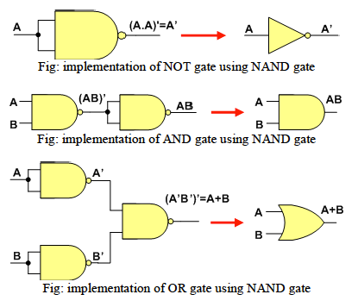

**Experimental Procedure:**

* At first, we need to verify each of the NAND gate equivalent circuits to perform the same operations of the basic gates.
* Then we have to construct and test the implementations of XOR and XNOR gates using NAND gates only.
* Then again, we have to construct and test the implementations of NOT, AND, OR, XOR and XNOR gates using NOR gates only.
* Then we have to complete the truth table for Figure 1 in Table 1.
* Then we have to convert the circuit in Figure 1 to a NAND gate equivalent circuit.
* Then in Part 1 of ‘Data Sheet & Circuit Diagrams’ we have to replace each of the gates with its NAND gate equivalent.
* And in Part 2 if there’s repeated number of NAND gate one after another then we can remove those 2 gates and redraw the circuit as the results will be same.
* Finally, we need to verify our circuit using the truth table in Table 1.

**Question/Answer:**

**IC Diagram:**

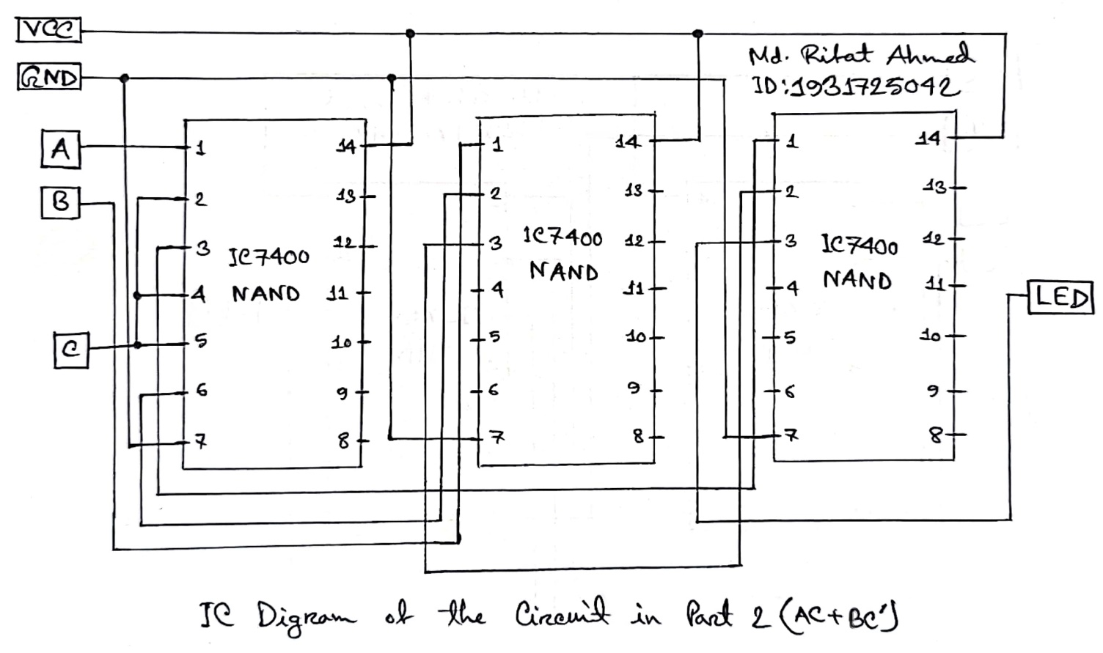

**Discussion:**

Through this lab we learned about the universal gates. We started by simulating circuits built using only the universal gates (NAND, NOR). And so, we learned how to build the basic gates using the universal gates. After that we built XOR and XNOR gates using only NAND gates. Then we build NOT, AND, OR, XOR and XNOR gates again but this time using only NOR gates. After that we completed the truth table for a given Boolean function of a combinational circuit. After that we build that same circuit using only NAND gates. Then we saw that where a NOT gate is followed by another NOT gate if we remove both of them the results still remain the same. So, we removed those gates from the circuit for our part 2 of the circuit diagram and simulated the circuit. Then we verified the result of the circuit using the truth table that we had completed before starting to simulate our circuit. So overall, in this experiment we learned a lot of new things about universal gates and making different circuits using only NAND or NOR gates. The only negative part is that we couldn’t do the experiment in physical lab.

**Data Sheet & Circuit Diagrams:**

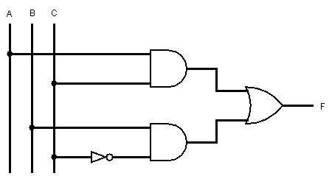

**Figure 1: A combinational circuit**

|  |  |
| --- | --- |
| XOR | XNOR |

**Figure 2: Implementation of XOR and XNOR using NAND gates**

|  |  |  |  |
| --- | --- | --- | --- |
| NOT | AND | | OR |
| XOR | | XNOR | |

**Figure 3: Implementation of NOT, AND, OR, XOR and XNOR using NOR gates**

|  |  |  |  |
| --- | --- | --- | --- |
| **A B C** | **I1**= AC | **I2**= BC’ | **F** = I1 + I2 |
| 0 0 0 | 0 | 0 | 0 |
| 0 0 1 | 0 | 0 | 0 |
| 0 1 0 | 0 | 1 | 1 |
| 0 1 1 | 0 | 0 | 0 |
| 1 0 0 | 0 | 0 | 0 |
| 1 0 1 | 1 | 0 | 1 |
| 1 1 0 | 0 | 1 | 1 |
| 1 1 1 | 1 | 0 | 1 |

**Table 1: Truth table of combinational circuit in Figure 1**

|  |
| --- |
| Part 1 |
| Part 2 |

Figure 4: Universal (NAND) gate implementation of the circuit of Figure D2

**Simulation:**

Simulating the circuit:

